# **LoL Expert Content and Game Design Review**

**Game**

* Project Bloom: Climates and Weather

### **Learning Objective (LO)**

* Climates

**Game URL:**

* <https://app.legendsoflearning.com/game/project-bloom-climates-and-weather/1803?partner=legends-internal&game_version_id=11423&review=true>

**LO Document:**

* [3-ESS2.D-2_Climates_GameSpecs.docx](https://drive.google.com/file/d/1I-FmGfCZg_5isIwtFygLR2TPSdJ2Qz66/view?usp=sharing)

**LO Main Concepts:**

* Main Concepts that aren’t checked by the LoL Reviewer are not present in the game or could be taught better.

| **Concept** | **Current Alignment** | **LoL Content Reviewer** |
| --- | --- | --- |
| Weather is defined as the conditions of the atmosphere at a particular place and time. | ✓ | ✓ |
| Some measures of weather include temperature, precipitation, and wind direction. | ✓ | ✓ |
| Coastal climates typically have year-round precipitation and a narrow range in temperature between summer and winter. | ✓ | ✓ |
| Coastal climates are found along ocean coastlines. | ✓ | ✓ |
| Climate describes the typical weather conditions in an area over a long period of time. | ✓ | ✓ |
| Climate in a region can change over the course of years to centuries, depending on natural factors and human activities. |  |  |
| Climate zones are determined by the latitude of the region. | ✓ | ✓ |
| Climate types are determined by the geography of a region, such as proximity to mountains and oceans. | ✓ | ✓ |
| Major climate types are classified according to average temperature and precipitation. | ✓ | ✓ |
| In tropical climate zones, weather is typically hot all year long and can be wet or dry. | ✓ |  |
| Tropical climate zones are typically located near the equator. | ✓ |  |
| In temperate climate zones, the summers and winters have milder temperatures and variable precipitation. | ✓ |  |
| In polar climate zones, temperatures are cold all year and tend to be dry. | ✓ | ✓ |
| Polar climate zones are located closer to Earth’s north and south poles. | ✓ | ✓ |
| Dry climates receive very little precipitation while wet climates receive more precipitation. | ✓ | ✓ |
| Continental climates are found inland, away from oceans. | ✓ | ✓ |
| Continental climates typically have a large range in temperature between summer and winter. | ✓ | ✓ |

# 

# 

# **Content Review**

**Overall Rating (1-5): 3.75**

**Ease of Play Rating (1-5): 3.5**

**Content Integration Rating (1-5): 4 🔥**

**Things we liked:**

* You included a button for students to see where the equator is located. This helps since not all students have the same background knowledge.
* Nice distinction between climate and weather.

**General Feedback (ordered by level of importance)**

**1.**

**Feature:**

* **Some vocabulary is too high for this grade level**

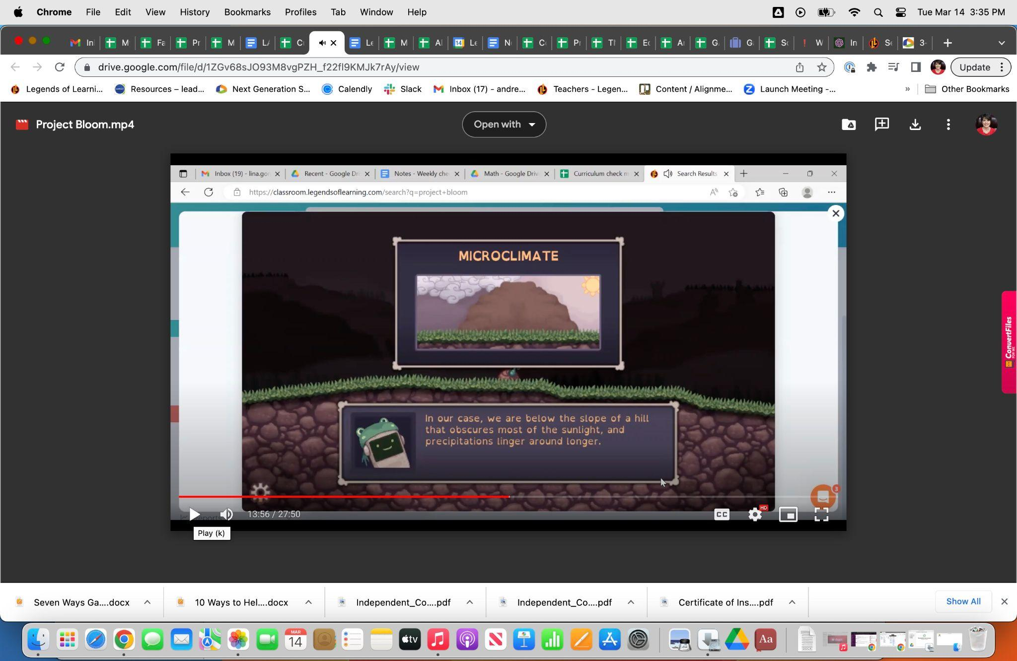

**Why is it important?**

* It is important to use appropriate vocabulary for 8-year-olds, so they can comprehend what they are learning.

**Our recommendations:**

* Remove this section since the vocabulary is too high, and it exceeds the expectations of the learning objectives. Plus it will cut down on the length of the game.
* Also, in the portion of the game with the frogs the word traverse is used (3rd graders will not know what that means)

**2. Feature:**

* **Game is too long**

**Why is it important?**

* Teachers only have 30–45 minutes to teach science in elementary school. In order for students to get through the entire game, it should only be about 10–15 minutes in length.

**Our recommendation:**

* Remove the content that does not deal with climate and weather.

# **Developer Questions**

1. Coastal Climates – What is missing in the game regarding this concept? The second level deals with this when the student selects the British Isles, and have to deal with a constant weather pattern of overcast and rain.

I added the ✓ for this but I missed it because I was looking for coastal climate wording.

1. Vocabulary – Is this specific to the microclimate section? Are there other specific lessons in the game where this needs to be looked at?

Yes, here are some examples of vocab that is too high (deploy)- severe weather section: havoc, perilous) Traverse

1. Content that does not deal with climate and weather – Can you guys be specific on this? The core of the game does show the player how the climate affects day-to-day activity, as well as looking at the weather pattern.

The cycles – maybe just go through one cycle each time to make the game shorter. The appropriate amount of time for a student of this age would be 10-15 minutes. You will have more people assign the game if it is shorter, since teachers do not have a large block of time to teach science in elementary school.

# **Game Design Review**

**Overall Rating (1-5): 4.6 🔥**

**Things I liked:**

* Love the music!
* Art looks great!
* This is a really well-made and polished game
* Lot and lots of info (maybe even too much for the scope of this grade level)
* Nice evaluation portion at the end
* I like frogs lol

**Game Design Feedback:**

* The focus should be on upping the teacher rating of 3.6
* I think the design and depth of this game may be better suited for a grade 6-8 game rather than 3-5
* Fast paces click and drag could be difficult for players without mice using the Chromebook trackpad.
* It can be a bit hard to identify what's going on, zooming in the camera and slowing down the gameplay pace may help.
* I could see the game taking longer than the ETA of 17 min for younger students. 15-20 min is ideal. Sometimes less is more, you could remove some cycles while still keeping all the climates.



* This game may actually align better with the middle school version of [Weather and Climate](https://drive.google.com/file/d/1p5Yk3JNJUejWAimRI4LFcppuIQZPLdJZ/view) and fit better with that target audience. Or maybe a slightly edited version of this game could go in that LO.

# **Developer Questions**

1. Gameplay length – If I were to remove one cycle for each level, will that suffice? If it is, will there be room to add a Tropical level to satisfy the Tropical Climate concept?

Removing a cycle from each level would definitely help! I wouldn't add a new level because it would likely make the game about the same length as before. You could remove the cycles first and test//time it before deciding.

Omitting Tropical is probably the best of the biomes/climates to leave out in my opinion. Since there isn't any in the continental US. Maybe there is a way to reference it without having a whole level.

1. Game difficulty – How much does this actually affect regarding teacher rating? This game is rated fairly high by students, so I’m hesitant to put too much effort on this.

This could affect some teachers' ratings who are less familiar with games. More UI and gameplay that may not be intuitive to a non-gamer could dissuade them when it may seem obvious to people who play games (like 97% of students today).